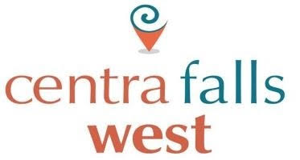

CENTRA FALLS WEST HOMEOWNERS’ ASSOCIATION, INC.
  - Board of Directors Meeting Agenda
Date: April 8th, 2026 Time: 6:30 PM
Location: 1786 NW 124th Way Pembroke Pines, FL 33028
Virtual: https://meet.google.com/ojz-dceu-veh | Dial-in: (US) +1 401-889-4134‬ PIN: 710 327 999‬#‬‬‬‬

1. Call to Order

2. Confirmation of Proper Meeting Notice
Notice provided in accordance with Chapter 720, Florida Statutes, and the Association’s governing documents.

3. Roll Call of Directors and Officers

4. Verification of Quorum
☐ Quorum established ☐ Quorum not established

5. Approval of Previous Meeting Minutes
March 25, 2026 Board Meeting Minutes

6. Guest Speaker
William Deere – Insurance Renewal Presentation

7. Ratification of Actions Taken Between Meetings
- Approval of Payment Plans for Homeowners
- Emergency Gate Upgrade – 124th Way (Full System Replacement)
  - Ratification of Board approval conducted via email due to urgency
  - Replacement cost exceeds $9,000 and will be funded from Reserves

8. New Business (Discussion and Possible Action)
- Vehicle Sticker Procedure (Interior vs. Exterior Stickers)
- Board Roles & Responsibilities / Operational Structure (Self-Managed)
- Tenant Security Deposit Responsibility & Process
- Resident Welcome Packet (Review and Updates)

9. President’s Report

10. Treasurer’s Report

11. Committee Reports

12. Operations & Maintenance Updates

13. Old Business

14. Adjournment

Homeowner Q&A / Open Forum
Held after adjournment. No Board action will be taken.

